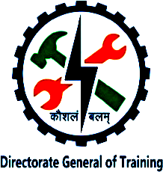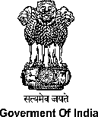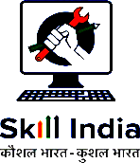

NATIONAL SKILL TRAINING INSTITUTE (NSTI) KOLKATA, DASNAGAR, HOWRAH

LESSON PLAN
NAME:- Ankita singh TRADE/ROLL NO.- CITS/CSA/25-26/Y/1420
UNIT/LESSON NO:- 8 DATE & TIME:- 10-10-2025
- PREPARATION

TITLE/TOPIC:- multimedia

OBJECTIVES:
a). define multimedia.
B define types of multimedia.
INTRODUCTION:
REVIEW / LINK/ MOTIVATION :- through examples
- PRESENTATION :
OBJECTIVES | INFORMATION POINTS | SPOT HINTS
multimedia | Multimedia is a broad topic with applications in many fields including many fields , education entertainment .  And business, because it enhances user engagement and understanding compared to traditional single -media formats. 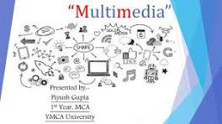  - The word itself, sometimes spelled with a hyphen as multi-media, has been used since 1962, from multi-, or "many," rooted in the Latin multus, "many or much;" and media, the plural form of medium, | Broad topic like education and entertainment  history

OBJECTIVES | INFORMATION POINTS | SPOT HINTS
Text  Images  Audio  Vedio  animation | - The written word, such as in a book, on a website, or in a presentation.  - Still visual representations, including photographs, diagrams, and graphics.  - : Sound-based content, such as voice narration, music, or sound effects.  - Moving pictures with accompanying audio, like films, recorded lectures, or animations.  - Creating the illusion of motion from a series of static images, which can range from simple graphics to complex 3D models. | Book  Photographs  Music  Animations  3D MODELS
- APPLICATION : a).....what is multimedia
- Types of multimedia
- c)different uses of multimedia
.
SUMMARY : To repeat the objectives/main points once again.
Repeat the objectives in short

- TEST/QUESTIONS : a)..what is multimedia?
- What are current usage?
- Advantages of multimedia?
ASSIGNMENT:
- Make a file describing different types of multimedia?

Reference:....google, wikipedia......etc NEXT LESSON :security monitoring and control.....

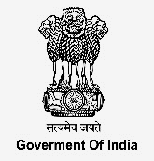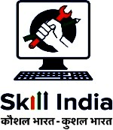

NATIONAL SKILL TRAINING INSTITUTE (NSTI) KOLKATA, DASNAGAR, HOWRAH

INFORMATION SHEET

TITLE/TOPIC: SKILL AND ITS BASIC ELEMENTS

INFORMATION:
Multimedia is the use of a combination of different content forms like text, graphics, audio, animation, and video to deliver information or entertainment. It is a computerized method that integrates these elements into a single, often interactive, presentation. The term "multi" signifies many, and "media" refers to the different forms of content used.
Key aspects of multimedia
- Combination of content:
It combines various forms of media that can be both time-independent (like text and images) and time-dependent (like audio and video).
- Interactive and engaging:
Multimedia is often used in an interactive way, allowing the user to navigate, engage, and communicate with the information presented.
- Digital and computer-controlled:
It relies on computer technology to represent, store, transmit, and process information digitally.
- Applications:
Multimedia is used widely in fields such as education, training, business presentations, and entertainment.
- Multimedia
Multimedia is a form of communication that uses a combination of different content forms writing, audio, images, animation...
multimedia types
- TEXT: The written word, such as in a book, on a website, or in a presentation.
- IMAGES: Still visual representations, including photographs, diagrams, and graphics.
- AUDIO: Sound-based content, such as voice narration, music, or sound effects.
- VEDIO: Moving pictures with accompanying audio, like films, recorded lectures, or animations.
- ANIMATION: Creating the illusion of motion from a series of static images, which can range from simple graphics to complex 3D models.

